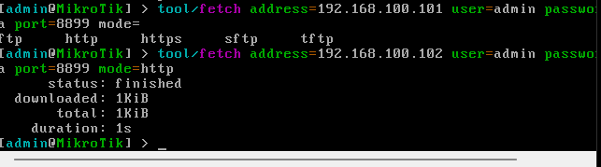
IP adresa=192.168.100.250

